**Saklayen Ahmed**

Care of Taz Uddin Ahmed, Kewa Pashchim Khanda, Sreepur, Gazipur

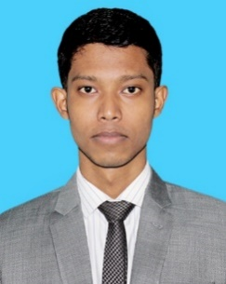**Mobile:** +8801727-268458, +8801623-211729

**E-mail:** [saklayen.3221@gmail.com](mailto:saklayen.3221@gmail.com)

**Educational Backgrounds**

**Article Student**

Nurul Faruk Hasan & Co, Chartered Accountants (Deloitte Bangladesh Ltd)

**Employee ID:** 90203 (Senior Associate)

**Articleship Period**: April 06, 2021 to April 05, 2024

**Principal:** Mr Md Faruk Uddin Ahmed FCA, CISA

**Address:** Vertex Prominent (1st Floor), GA-16/1 Mohakhali, Dhaka-1212, Bangladesh

**Phone:** +88 096 1100 2202

**Chartered Accountancy**

Institute of Chartered Accountants of Bangladesh

**Registration No:** 33430/21

**Completed:** Passed 06 out of 17 Subjects

**Address:** CA Bhaban, 100 Kazi Nazrul Islam Avenue, Dhaka-1215, Bangladesh.

**Phone**: +88 096 1261 2100

**Master of Business Administration (MBA)**

Department of Accounting and Information Systems

University of Rajshahi

**Student ID:** 1510233221

**Passing Year:** 2019 (Exam held in 2021)

**Bachelor of Business Administration (BBA)**

Department of Accounting and Information Systems

University of Rajshahi

**Student ID:** 1510233221

**Passing Year:** 2018 (Exam held in 2019)

*Please turn over…*

**Higher Secondary Certificates (HSC)**

Business Studies

Gazipur Cantonment College

**Passing Year:** 2014

**Secondary School Certificates (SSC)**

Business Studies

Rajendrapur Cantonment Public School and College

**Passing Year:** 2012

**Personal Information**

**Father’s Name** : Tazuddin Ahmed

**Mother’s Name** : Manwara Begum

**Date of Birth** : April 25, 1997

**Marital Status**  : Single

**Religion** : Islam

**Permanent Address** : Village: Kewa Pashchim Khanda; Post: Mawna; Post Code: 1740

Upazilla: Sreepur; District: Gazipur.